Voya Face & Body

Raise your organic skin care expectations!

As a truly niche brand, Voya are a family business focused on creating genuinely organic, seaweed-based products and spa treatments.

Wild organic seaweeds are harvested by hand on the West coast of Ireland and combined with the highest quality botanical ingredients and aromatherapy oils, to create a range of products and treatments that achieve exceptional results, whilst being sustainably produced and are certified by the Soil Association.

Germaine de Capuccini

Our Wellness Therapies help to restore and soothe mind, body and soul, using carefully selected products to target skin-related side effects caused by chemotherapy, radiation and strong medication. Uses light touch massage, thus suitable for cancer patients, those with long term illness or anyone in need of a completely de-stressing experience.

Caudalie

Caudalie is a glamourous, French brand that combines the latest scientific techniques with natural ingredients. A Caudalie product delivers luxurious textures and aromas that are a delight on the skin; whilst delivering exceptional results. Our therapists are extensively trained to deliver the ultimate in luxurious, indulgent treatment experiences, which are globally recognised as a must-have treatment experience.

Jessica

When it comes to natural nails, Jessica Cosmetics is considered a world-leading brand with a range of nail products to achieve and maintain naturally beautiful nails.

Ashmira Botanica Waxing

This exquisite waxing range is packed with botanical elements from Mother Nature. Every product has wonderful ingredients such as argan oil, that have been chosen for their exceptional moisturising and anti-inflammatory properties, to help repair, protect and nourish skin after hair removal.
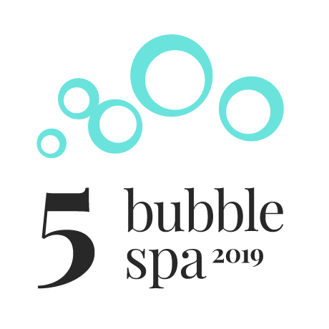

Caudalie Fleur de Vigne Candle Massage

60 mins £70

This unique massage treatment indulges all your senses. Using a massage candle which melts into a luxurious warm, delicately scented oil, it will soothe aching muscles and leave the skin softly scented and richly hydrated.

Voya Traditional Massage

30 mins £55 | 60 mins £75

Using Voya oils, this massage is designed to soothe tired and aching muscles, nourish the skin and help aid relaxation.

Baobab Body Ritual Massage

90 mins £90

This Germaine de Capuccini relaxing and indulgent ritual uses ethically sourced, organic baobab oil packed with antioxidants, vitamins and omegas to nourish and protect the skin. Your ritual begins with a gentle full body exfoliation using baobab seeds. Soothing lymphatic massage with baobab oil provides the skin with anti-inflammatory nourishing and hydrating benefits.

Lava Shells Relax Massage

90 mins £100

This warming massage uses gentle heat in porcelain shells in conjunction with your therapist’s hands to deploy deeply therapeutic relief where needed. Finishing with a sublime massage, this is a seriously relaxing treatment.

Voya Reflexology

45 mins £60

A therapy that can be dated to ancient Egypt, India and China; reflexology is a gentle pressure point massage treatment, which uses reflex areas on the feet linked to areas and organs in the body. This relaxing therapy can help identify physical factors that may be affecting your well-being and help to restore balance naturally.

Voya Foot Retreat Ritual

45 mins £60

This treatment begins with a sea salt exfoliation from the knees to the feet to refine your skin. You will then be treated to a deeply relaxing massage of the lower legs, a double action seaweed foot mask and fresh seaweed leaf wrap to reduce swelling and soften tired feet. This is an ideal treatment during pregnancy.

Bath Butler

15 mins preparation £30

In the comfort and privacy of your hotel room, allow the Spa Bath Butler to prepare a warm bath for you with wild hand-harvested seaweed. The mineral rich seaweed soothes aches and pains and aids in the healing of skin conditions such as psoriasis and eczema. It is also deeply detoxifying, and induces a deep sleep, or try it before a spa treatment to relax your muscles and soften skin. Enjoy relaxing in your bath for as long as you like!

Organic Exfoliations For All Skin Types

45 mins £60

Each treatment begins with body brushing to stimulate the lymphatic circulation and ends with an application of body lotion, leaving you feeling invigorated and your skin feeling super soft.

Caudalie Cabernet Sugar Scrub
Grape seeds, honey & brown sugar, stimulates circulation.

Voya Peppermint & Seaweed Sugar Glow
Uplifts & refreshes.

Caudalie Divine Glow
Gentle & nourishing with a glamourous scent.

Voya Lavender & Seaweed Sugar Glow
Healing & relaxing.

Jessica nail products help to restore moisture and care for your nails as naturally as possible. Your nails are treated with a base coat especially chosen to treat problems such as peeling, breaking or dryness. We use a new polish for every manicure, which is yours to take home.

Alternatively, you can have gel polish applied which dries instantly.

Time-Precious Manicure | Pedicure

45 mins £40

Perfect for when you are short of time, or if you have regular nail treatments, this includes nail cutting and filing, tidying of cuticles and an application of polish which is yours with our compliments. Or, if you have a special occasion or holiday coming up, you may want to try a gel polish which will stay chip-free for 2 weeks and dries instantly.

ZenSpa Manicure | Pedicure

60 mins £55

If your feet have been neglected, or they need a bit of extra care, then the ZenSpa pedicure includes nail cutting, filing and cuticle work, as well as exfoliation, hard skin removal and massage. To finish you can either choose the regular nail polish, which is yours to take home, or have a coat of gel polish which will dry instantly.

Gel Removal

30 mins £15

Removal of gel and, if time allows, file, buff and oil.

(Removal is free if part of a manicure of pedicure).

NB: If you are having an application of regular nail polish, it is not advised to swim, shower or use any heat treatments such as the sauna, for at least 3hrs.

Full Leg Wax
£35

Half Leg Wax
£25

Standard Bikini Wax
£20

Underarm Wax
£18

Back or Chest Wax
£25

Please note: no sunbathing or heat treatments (for example sauna | steam room) for 24 hours before or after waxing. Swimming and massage treatments are not recommended after waxing.

