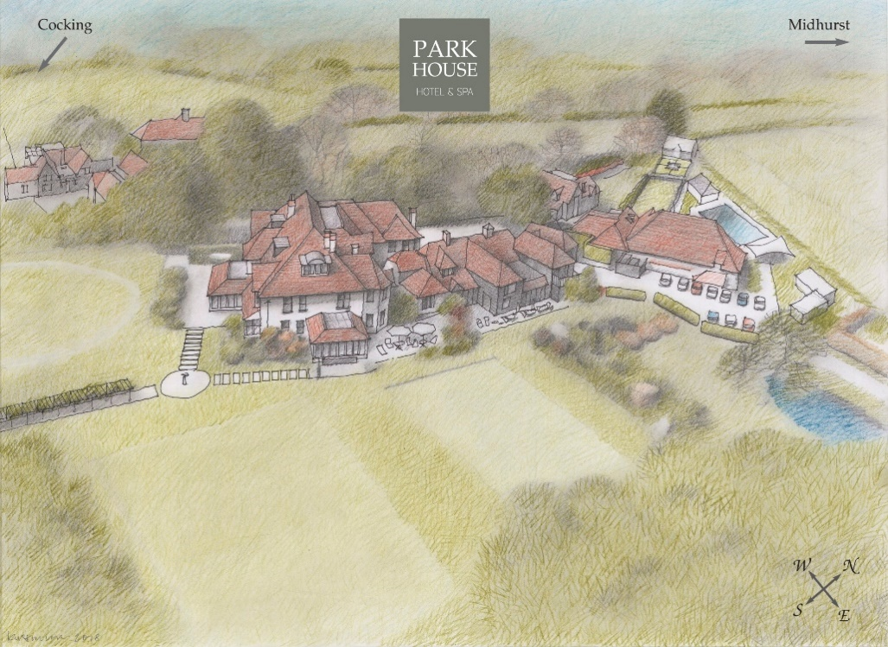

WINE LIST
The 2020 list at Park House includes a selection of 120 wines.

We have worked closely with selected local family wine merchants to create
an elegant selection for your enjoyment. The restaurant team is on hand
to offer guidance and to serve our wines with passion and enthusiasm.

Most of our wines contain sulphites. Prices include VAT. Trade Description Act: it is not possible to guarantee
continuity of all vintages and producers in this list and in some cases a suitable alternative may be saved

By the Coravin
A selection of fine wines served in 125ml measures using the Coravin wine system,
enabling us to pour a selection of our exclusive wines without having to remove the cork.
The perfect opportunity for you to try something rare and special.

White Wine 125ml
220 Domaine Brocard, Chablis ‘Les Blanchots’ Grand Cru 2014, Burgundy, France £21
211 Ladoucette, Baron De L Pouilly Fume 2014, Loire, France £25

Red Wine
413 Chateau Batailley 2011, 5eme Cru Pauillac, Bordeaux, France £22
420 Pio Cesare, Barolo 2014, Piedmont, Italy £21

Wines from England
English wine has soared in popularity over the last decade due to its improved quality.
Our selection is locally produced and predominantly within 50 miles.
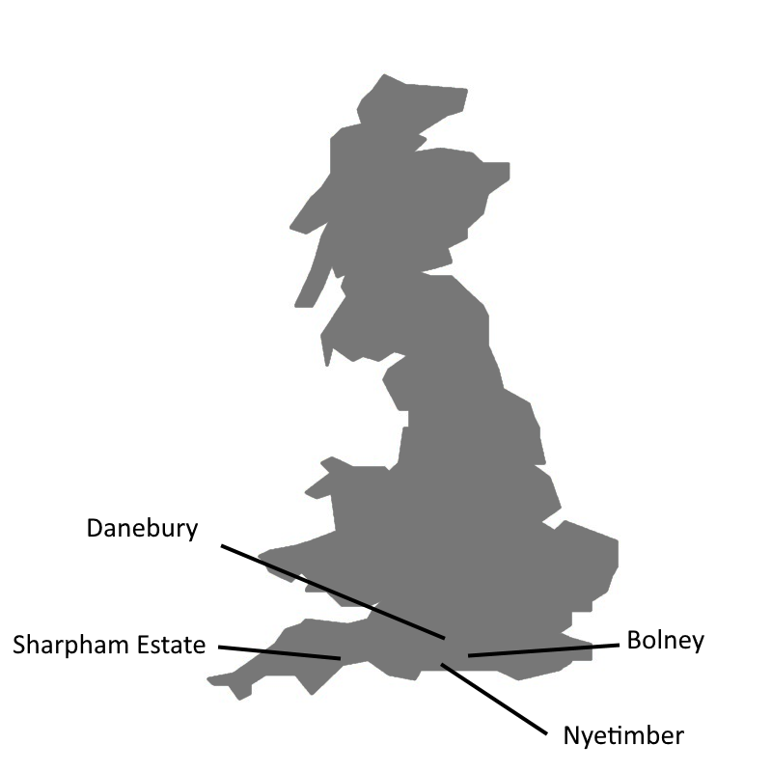
Nyetimber Wine “I don’t think in years but in generations”. Eric Heerema, Owner.

125 Classic MV, Nyetimber, Sussex £75
126 Blanc de Blancs 2010, Nyetimber, Sussex £90
127 Rose MV, Nyetimber, Sussex £85
123 ½ Classic MV, Nyetimber, Sussex, England £40

Red Wine
404 Lychgate Red 2016, Bolney, Sussex £42
405 Pinot Noir 2017, Bolney, Sussex £52
417 Pinot Noir 2014, Welcombe Hills, Warwickshire £40

White Wine
204 Dart Valley Reserve 2017, Sharpham, Devon £38
205 Reserve 2017, Danebury, Hampshire £33
206 Madeleine Angevine 2017, Danebury, Hampshire £33
201 Schonburger 2017, Danebury, Hampshire £33
241 Pinot Gris 2018, Bolney, Sussex £50
242 Lychgate Bacchus 2018, Bolney, Sussex £40
213 Bacchus/Sauvignon 2014, Welcombe Hills, Warwickshire £45

Sparkling Wine
114 Bubbly NV, Bolney, Sussex £50

Wines from France
For hundreds of years, France basked in the reputation of being the world's greatest
producer of wines. It still offers some of the best wines, with the greatest variety,
and excellent value for money, even from the main wine areas.

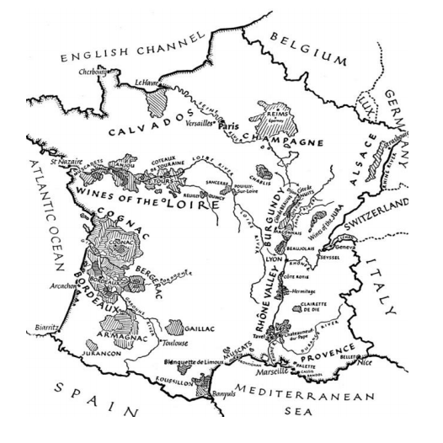

Joseph Perrier “Joseph Perrier was founded in 1825 and is one of the very smallest Grande Marque houses in Champagne. Currently run by Jean-Claude Fourmon, the fourth generation of his family to own this vineyard”.

101 Brut NV £70
102 Blanc De Blanc NV £95
116 ½ Brut NV £38
117 ½ Brut Rose NV £45
103 Rose NV £90
104 Brut 2008 £100
105 Josephine 2008 £230

Champagne
118 Louis Roederer, Brut Premier NV £100
119 Louis Roederer, Blanc De Blanc 2010 £170
120 Louis Roederer, Cristal 2009 £375
106 Dom Perignon 2009 £300
107 Laurent Perrier, Rose NV £140
108 Billecart Salmon, Rose NV £120
110 Bollinger, Special Cuvee NV £100
111 Taittinger, Brut Reserve NV £100
112 Pol Roger, Brut Reserve White Label NV £100

Sparkling Wine
109 La Grande Marque, Saumur NV, Loire £36

White Wine
207 Macon-Bussieres Villages 2017, Gonon, Côte de Beaune £35
208 Sancerre 2018, Domaine Vacheron, Loire £54
209 Chassagne-Montrachet 1er Cru 2017, Bachey-Legros Burgundy £86
210 Meursault Les Grands 2017, Bachey-Legros, Cote de Beaune £86
211 Baron De L Pouilly Fume 2015, Ladoucette, Loire £110
212 Tariquet Classic 2017, Côtes de Gascogne £25
214 Chablis 2018, Malandes, Burgundy £54
220 Chablis ‘Les Blanchots’ Grand Cru 2017, Brocard, Burgundy, £110
216 Pouilly-Fuisse Les Crays 2017, Auvigue, Burgundy £62
217 Picpoul De Pinet 2018, A Morin, Languedoc £25
226 Petit Chablis 2017, Malandes, Burgundy, France £48

Rosé Wine
303 Chemin Des Pelerins 2016, Saint Mont, Pyrenees £25
301 Rose De Sophie 2017, Famille Sumeire, Côtes de Provence £33
305 Whispering Angel 2017, Côtes de Provence £49

Red Wine
406 Chateau Cissac 2015 Cru Bourgeois, Haut Médoc, Bordeaux £50
407 Bourgogne Pinot Noir 2014, Parent, Burgundy £52
408 Cote Du Brouilly 2016, Thivin, Beaujolais £58
409 Fleurie 2017, Cave de Fleurie, Beaujolais £36
410 Tabuteau 2016, Lussac-Saint-Émilion, Bordeaux £36
411 Châteauneuf De Pepe 2015, Vieux Telegramme, Brunier, Rhône £75
412 Gevrey-Chambertin 2016, Rossignol-Trapet, Burgundy £90
413 Batailley 5eme Cru 2011 Pauillac, Bordeaux £125
414 Margaux 1er Cru 1989, Bordeaux £600
415 De Pez 2014, Saint Estephe, Bordeaux £105
416 Mercurey 2015, Faiveley, Burgundy £58
418 Nuits St George Vielles Vignes 2015, Alain Michelot, Burgundy £105
401 Schroder & Schyler Reserve 2016, Medoc, France £50

Wines from Italy
Italy is home to some of the oldest wine-producing regions in the world
and its wine regions are known for their rich variety of wine styles.

Sparkling Wine
113 Amori, Prosecco Extra Dry, NV £36

White Wine
219 Verdicchio 2018, Castelli Jesi, Marche £27
202 Carlomagno/Fiano 2017, Cantino Paolo Leo, Puglia £27
221 Catarratto/Pinot Grigio 2018, Fedele, Sicily £26
222 Gavi Di Gavi 2018, Cantine Manfredi, Piedmont £36
223 Grillo 2017, Rupe Secca, Sicily £27

Red Wine
420 Barolo 2014, Pio Cesare, Piedmont £110
402 Nero D’alvola 2017, Fedele, Trapani £26
421 Brunello Di Montalcino 2014, Donatella Colombini, Siena £85
Wines from Romania
Although winemaking in Romania dates back centuries, it’s only recently been exported. During the late 19th century disease ruined many vineyards, but it has recovered by introducing French varieties such as Pinot Noir and Cabernet Sauvignon.
White Wine
218 Sauvignon 2015, Lautarul, Timisoara £27

Red Wine
419 Pinot Noir 2016, Lautarul, Timisoara £27

Wines from Chile
Introduced to Chile by the Spanish conquistadors in the 16th century,
the Chilean wine industry exploded onto the world stage in the late 20th century.

White Wine
229 Chardonnay 2018, Ladera Verde, Central Valley £25
230 Gewurztraminer Reserva 2017, Alto los Romeros, Colchagua Valley £27

Red Wine
433 Pinot Noir 2016, Dancing Flame, Central Valley £28
434 Cabernet Sauvignon 2018, Ladera Verde, Central Valley £27

Wines from the USA
Until the 1960s American wine was inexpensive and domestically consumed.
With the explosion of the Californian wine region it is now one of the world’s largest producers.

White Wine
227 Chardonnay 2016, Ca Momi, Napa Valley £42

Red Wine
436 Zinfandel 2016, Ironstone, California £44
435 Pinot Noir Long Barn 2016, For di Sole, California £30
437 Cabernet Sauvignon 2016, Ca Momi, Napa Vally £60
440 Merlot 2015, Markham, Napa Valley £70

Wines from Argentina
Argentine wine has its roots in Spain when vines cuttings were
brought over during the Spanish colonisation of the Americas.
White Wine
228 Torrontes 2018, Gouguenheim, Mendoza £28
234 Sauvignon Blanc 2018, Finca Sophenia, Mendoza £32
235 Chardonnay 2017, Famillia Schoeder, Patagonia £31
Red Wine
431 Flores Del Valle Blue Melosa 2014, Gougenheim, Mendoza £48
425 Cabernet Sauvignon 2014, Gougenheim, Mendoza £33
422 The Blend Synthesis 2014, Finca Sophenia, Mendoza £74

Wines from Spain
Spain is famous for producing many red and white varieties, but it’s impossible to mention
wine production in Spain without referencing Rioja or Cava, two of its most famous exports.
Sparkling Wine
115 Cava d’olerdola NV, Castillo Perlade, Penedes £36
White Wine
224 Rioja Blanco 2018, Bodega Bagordi, Rioja £28
239 Albarino 2018, Condes de Albarei, Rias Baixas £34
Rosé Wine
306 Rioja Rosado 2017, Bodega Bagordi, Rioja £28
Red Wine
423 Rioja Crianza 2015, Bodega Berceo, Rioja £32
Wines from New Zealand
New Zealand’s wine industry is extremely new. Although vines were planted in the early 19th century, it wasn’t until the 1970s it made headway in the wine world.
White Wine
232 Sauvignon 2018, Gimblett Gravels, Hawkes Bay £34
233 Pinot Gris 2018, Domain Road, Otago £40
243 Sauvignon Blanc 2018, Warirau River, Marlborough £38
244 Target Riesling 2015, Mount Difficulty, Central Otago £45
Red Wine
442 Merlot 2014, Gimblett Gravels, Hawkes Bay £40
444 Pinot Noir 2014, Alan Mccorkindale, Waipara Valley £58
456 Syrah 2016, Schubert, Martinborough £85
Wines from South Africa
Although referred to as New World wine, it has been produced in
the Cape since the mid-17th century.
White Wine
237 Chardonnay 2018, Meerlust, Stellenbosch £54
203 Viognier 2018, Wide River, Breede River Valley £27
238 Big Easy Chenin 2017, Ernie Elis, Stellenbosch £30
215 Chardonnay 2019, Freedom Cross, Franschoek £27
Red Wine
445 Rubicon 2015, Meerlust, Stellenbosch £65
447 Merlot 2015, Meerlust, Stellenbosch £54
451 The Chocolate Block 2016, Boekenhoutskloof, Franschhoek Valley £58

Wines from Australia
Australia has almost 2,000 wine producers. Although it has no native grapes, varieties were introduced by Europe and South Africa, predominantly Shiraz, Cabernet Sauvignon,
Chardonnay, Merlot, Semillion, Pinot Noir, Riesling and Sauvignon Blanc.
White Wine
231 Chardonnay 2016, Juniper Crossing, Margaret River £35
236 Chardonnay 2017, Sunnycliff, Victoria £28
240 Semillon 2017, Paulett, Clare Valley £32
249 Riesling 2017, Paulett, Clare Valley £32
Red Wine
439 Shiraz 2016, Juniper Crossing, Margaret River £35
441 Pinot Noir 2017, Tyrells, Hunter Valley £37
448 Shiraz Jackos Blend 2013, Geoff Merrill, McLaren Vale £42
449 Grenache/Shiraz, 2014, Mitchell, Clare Valley £35

Dessert Wines
A selection of sweet wines, served with dessert, featuring concentrated fruit flavours.

601 Sauternes, Petit Guiraud, Bordeaux, France £40
602 Tokaji, Aszu 5 Puttonyos 2009, Tokaj, Hungary £42
603 Black Muscat, Pfeiffer, Victoria, Australia £35

Wines by the Glass
A selection of wines served by the glass

Sparkling 125ml
101 Joseph Perrier, Brut NV, Champagne, France £11
125 Nyetimber, Classic MV, Sussex, England £12.50

White Wine 175ml 250ml Carafe
201 Reserve, Pinos Gris/Schonburger 2016, Danebury, Hampshire, UK £10 £13 £25
229 Chardonnay 2018, Ladera Verde, Central Valley, Chile £7 £10 £19

Red Wine 175ml 250ml Carafe
409 Fleurie 2017, Cave de Fleurie, Beaujolais , France £9 £12 £23
490 Grenache/Shiraz, 2014, Mitchell, Clare Valley, Australia £7 £10 £19

Rosé Wine 175ml 250ml Carafe
306 Rioja Rosado 2017, Bodega Bagordi, Rioja, Spain £7 £10 £19

Dessert Wine 125ml
601 Sauternes, Petit Guiraud, Bordeaux, France £12
603 Black Muscat, Pfeiffer, Victoria, Australia £12

Wines by the Glass
A selection of wines served by the glass

Sparkling 125ml
101 Joseph Perrier, Brut NV, Champagne, France £11
125 Nyetimber, Classic MV, Sussex, England £12.50

White Wine 175ml 250ml Carafe
201 Reserve, Pinos Gris/Schonburger 2016, Danebury, Hampshire, UK £10 £13 £25
999 Manager Selection from the cellar £7 £10 £19

Red Wine 175ml 250ml Carafe
409 Fleurie 2017, Cave de Fleurie, Beaujolais £9 £12 £23
888 Manager selection from the cellar £7 £10 £19

Rosé Wine 175ml 250ml Carafe
306 Rioja Rosado 2017, Bodega Bagordi, Rioja, Spain £7 £10 £19

Dessert Wine 125ml
601 Sauternes, Petit Guiraud, Bordeaux, France £12
603 Black Muscat, Pfeiffer, Victoria, Australia £12

